Food Delivery App SQL Analysis Project

SQL Analysis of a Food Delivery App Database

# Introduction:

This project uses SQL to analyze a custom food delivery app database, focusing on customer behavior, restaurant performance, and revenue trends to generate actionable business insights.

# Dataset:

MetaData:

| **Table Name** | **Primary Key** | **Foreign Key** | **Attributes** |
| --- | --- | --- | --- |
| users | user_id | NA | name, email, password |
| delivery | partner_id |  | partner_name |
| restaurants | r_id |  | r_name, cuisine |
| food | f_id |  | f_name, type |
| menu | menu_id | r_id, f_id | price |
| orders | order_id | user_id, r_id | amount, date, delivery_rating, restaurant_rating |
| order_details | id | order_id, f_id |  |

Relationships:

| **Tables** | **Relationship** |
| --- | --- |
| * users (1) —< orders (N) | * One to Many |
| * restaurants (1) —< orders (N) | * One to Many |
| * delivery (1) —< orders(N) | * One to Many |
| * orders (1) —< order_details (N) | * One to Many |
| * food (1) —< order_details (N) | * One to Many |
| * restaurants (1) —< menu (N) —> (1) food | * Many to Many |

# Tools:

* SQL
* RDBMS - MySQL
* Localhost
* Xampp
* Apache

# Problem Statement:

The food delivery app needs to understand customer ordering behavior and restaurant performance to improve growth and profitability.

# Business Questions:

### App Performance:

1. How much revenue does the app generate each month?
2. What is the app’s month-over-month revenue growth?

### Restaurant Performance:

1. Which restaurant has received the highest number of orders?
2. Which restaurant had the most orders in a given month?
3. Which restaurants generated monthly sales greater than 3,000 (or a specified threshold)?
4. Which restaurants have the highest number of repeat customers?

### Customer Behaviour:

1. Which customers have never placed an order?
2. What is the favorite dish of a specific customer?
3. What is each customer’s favorite dish?
4. Who are the most loyal customers for each restaurant?

### Order Details:

1. What is the average price of each dish?
2. What are the order details for a specific customer within a given date range?

# SQL Queries & Business Explanation:

## 

## App Performance:

### **Question:**

How much revenue does the app generate each month?

### **SQL Query:**

SELECT MONTHNAME(date) AS 'month',SUM(amount) AS 'TOTAL revenue' FROM orders

GROUP BY MONTHNAME(date)

ORDER BY MONTH(date);

### **Output:**

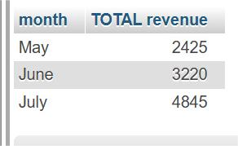

### **Business Insights:**

The app’s monthly revenue demonstrates strong and consistent growth. Overall, revenue nearly doubled within three months, signaling rising customer adoption, higher order frequency, and expanding restaurant engagement.

### **Question:**

What is the app’s month-over-month revenue growth?

### **SQL Query:**

SELECT month,(((revenue - prev)/prev) * 100) FROM

(

WITH sales AS

(

SELECT MONTHNAME(date) AS month,SUM(amount) AS revenue FROM orders

GROUP BY MONTHNAME(date)

ORDER BY MONTH(date)

)

SELECT month, revenue, LAG(revenue,1) OVER(ORDER BY revenue) AS prev FROM sales

) t

### **Output:**

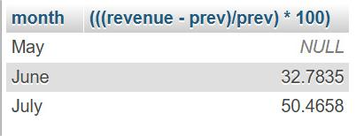

### **Business Insights:**

The app’s revenue grew by 32.7% in the second month and 50.4% in the third month, showing strong and accelerating growth driven by increasing customer adoption and engagement.

## Restaurant Performance:

### **Question:**

Which restaurant has received the highest number of orders?

### **SQL Query:**

SELECT r.r_name,COUNT(o.r_id) AS no_of_orders FROM orders o

JOIN restaurants r ON o.r_id = r.r_id

GROUP BY r.r_id

ORDER BY no_of_orders DESC

LIMIT 3;

### **Output:**

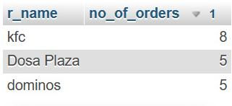

### **Business Insights:**

KFC received the highest number of orders (8), outperforming Dosa Plaza and Domino’s, which each received 5 orders. This indicates KFC’s stronger customer preference on the platform, suggesting opportunities to further leverage its popularity through promotions or featured placements.

### **Question:**

Which restaurant had the most orders in a given month?

### **SQL Query:**

SELECT r.r_name,COUNT(o.r_id) AS no_of_orders,MONTHNAME(date) AS month FROM orders o

JOIN restaurants r ON o.r_id = r.r_id

WHERE MONTHNAME(date) LIKE 'JUNE'

GROUP BY o.r_id

ORDER BY no_of_orders DESC

LIMIT 1;

### **Output:**

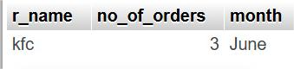

### **Business Insights:**

In June, KFC received the highest number of orders (3), highlighting it as the top-performing restaurant for that month. This indicates strong customer preference during the period and suggests potential for targeted promotions to sustain or boost demand.

### **Question:**

Which restaurants generated monthly sales greater than 3,000 (or a specified threshold)?

### **SQL Query:**

SELECT r.r_name,SUM(amount) AS total FROM orders o

JOIN restaurants r ON o.r_id = r.r_id

GROUP BY o.r_id HAVING SUM(amount) > 3000;

### **Output:**

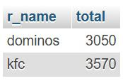

### **Business Insights:**

KFC (3,570) and Domino’s (3,050) both generated monthly sales above the 3,000 threshold. This indicates that these two restaurants are the top revenue drivers for the platform, making them key partners to focus on for sustaining growth and designing future promotional strategies

### **Question:**

Which restaurants have the highest number of repeat customers?

### **SQL Query:**

SELECT r.r_name,COUNT(o.user_id) AS no_of_customers FROM orders o

JOIN restaurants r ON o.r_id = r.r_id

GROUP BY o.r_id

ORDER BY no_of_customers DESC

LIMIT 3;

### **Output:**

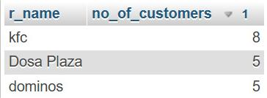

### **Business Insights:**

KFC has the highest number of repeat customers (8), indicating strong customer loyalty and satisfaction. This suggests that KFC is a key driver of customer retention on the platform and could be further leveraged through loyalty programs or exclusive promotions.

## Customer Behavior:

### **Question:**

Which customers have never placed an order?

### **SQL Query:**

SELECT user_id, name FROM users

WHERE user_id NOT IN (SELECT user_id FROM orders);

### **Output:**

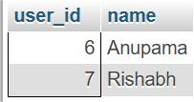

### **Business Insights:**

The analysis shows that customers Anumpama and Rishabh have never placed an order. This indicates inactive users on the platform, highlighting an opportunity to engage them through targeted onboarding campaigns, personalized offers, or reminders to encourage their first purchase.

### **Question:**

What is the favorite dish of a specific customer?

### **SQL Query:**

SELECT COUNT(f.f_id) no_of_orders,f.f_name,o.order_id FROM orders o

JOIN order_details od ON o.order_id = od.order_id

JOIN food f ON od.f_id = f.f_id

Where o.user_id = 1

GROUP BY f.f_name

ORDER BY no_of_orders DESC

LIMIT 1;

### **Output:**

SELECT COUNT(f.f_id) no_of_orders,f.f_name,o.order_id FROM orders o

JOIN order_details od ON o.order_id = od.order_id

JOIN food f ON od.f_id = f.f_id

Where o.user_id = 1

GROUP BY f.f_name

ORDER BY no_of_orders DESC

LIMIT 1;

### **Business Insights:**

Customers with ID 1 have ordered Choco Lava Cake five times, making it their favorite dish. This reflects a strong personal preference that can be leveraged through personalized recommendations or targeted promotions

### **Question:**

What is each cus**t**omer’s favorite dish?

### **SQL Query:**

WITH fav_food AS

(

SELECT o.user_id,f.f_name,COUNT(o.user_id) no_orders FROM orders o

JOIN order_details od ON o.order_id = od.order_id

JOIN food f ON od.f_id = f.f_id

GROUP BY o.user_id,f.f_id

ORDER BY no_orders DESC

)

SELECT u.name,ff.f_name,ff.no_orders FROM fav_food ff

JOIN users u ON ff.user_id = u.user_id

WHERE (ff.user_id, ff.no_orders) IN (

SELECT user_id, MAX(no_orders)

FROM fav_food

GROUP BY user_id

)

### **Output:**

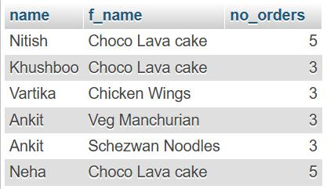

### **Business Insights:**

Identifying each customer’s favorite dish highlights individual food preferences across the platform. These insights can be used to personalize recommendations, design targeted promotions, and improve customer engagement, ultimately increasing order frequency and retention.

### **Question:**

Who are the most loyal customers for each restaurant?

### **SQL Query:**

WITH loyal_customers AS

(

SELECT o.r_id,o.user_id,COUNT(*) AS order_count

FROM orders o

JOIN users u ON o.user_id = u.user_id

GROUP BY o.r_id,o.user_id

ORDER BY o.r_id,order_count DESC

)

SELECT r.r_name,u.name,lc.order_count

FROM loyal_customers lc

JOIN users u ON lc.user_id = u.user_id

JOIN restaurants r ON lc.r_id = r.r_id

WHERE (lc.user_id, lc.order_count) IN ( SELECT user_id, MAX(order_count) FROM loyal_customers GROUP BY user_id)

AND order_count > 1

ORDER BY order_count DESC;

### **Output:**

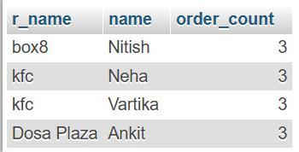

### **Business Insights:**

Identifying the most loyal customers for each restaurant provides valuable insights into customer–restaurant relationships. These customers demonstrate repeat purchase behavior, making them key drivers of stable revenue. Restaurants can strengthen loyalty further by offering exclusive deals, rewards, or personalized experiences, while the platform can use this information to enhance customer retention strategies.

## 

## Order Details:

### **Question:**

What is the average price of each dish?

### **SQL Query:**

SELECT f.f_name,AVG(price) AS average_price FROM menu m

JOIN food f ON m.f_id = f.f_id

GROUP BY f.f_name;

### **Output:**

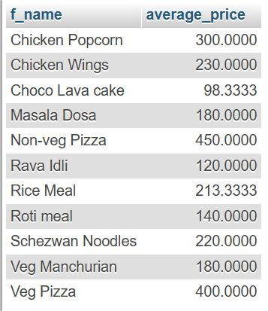

### **Business Insights:**

Calculating the average price of each dish provides insight into overall menu pricing trends on the platform. This helps identify whether dishes are competitively priced, highlights premium versus budget offerings, and supports decisions around pricing strategy, discount design, and customer affordability.

### **Question:**

What are the order details for a specific customer within a given date range?

### **SQL Query:**

SELECT * FROM orders

WHERE user_id = 1 AND date BETWEEN '2022-05-01' AND '2022-06-30';

### **Output:**

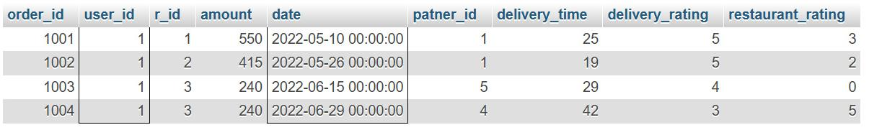

### **Business Insights:**

Analyzing the order details for a specific customer within a given date range provides a clear view of their purchase behavior during that period. This insight helps track order frequency, spending patterns, and preferred dishes, which can be used for personalized marketing, loyalty rewards, and improving customer engagement strategies.

## Key Business Insights:

The SQL analysis showed KFC as the top restaurant in orders and loyalty, with Domino’s among key revenue drivers. Revenue grew consistently by 33% and 50% month-over-month, reflecting strong customer adoption. Insights on favorites, loyalty, and inactive users highlight opportunities for personalization, retention, and re-engagement strategies

## Future Improvements:

**Expand Dataset** – Add more historical data (orders, customers, restaurants) to uncover seasonal trends and long-term patterns.

**Include Delivery Metrics** – Track delivery times, delays, and courier performance to analyze operational efficiency.

**Integrate Customer Feedback** – Add ratings and reviews to study satisfaction, sentiment, and quality of service.

**Advanced SQL Features** – Use window functions, stored procedures, and CTEs for deeper analysis.

**Data Visualization** – Build dashboards in Tableau, Power BI, or Python (Matplotlib/Seaborn) for interactive insights.

**Predictive Analysis** – Extend beyond SQL by applying machine learning to forecast revenue, order demand, or customer churn.

**Personalization Opportunities** – Use favorite dishes and loyalty analysis to design recommendation systems.

**Real-World Data Integration** – Compare results with actual food delivery datasets (Kaggle, public APIs) for validation.

## Project Conclusion:

This project used SQL to analyze a food delivery app database, uncovering insights on revenue growth, customer behavior, and restaurant performance. The findings highlight opportunities to boost engagement, improve retention, and support data-driven business decisions.